PROFILE - Bert van Manen

 |  | 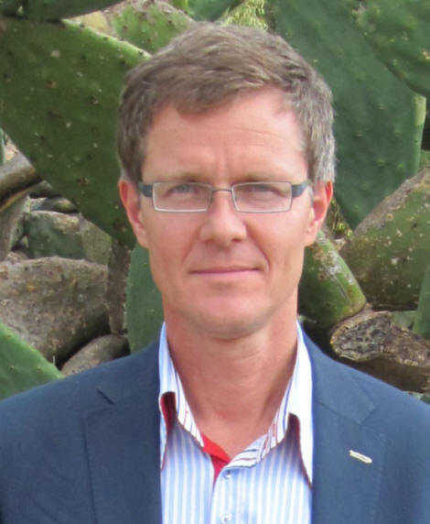
1 Family name  2 First names  3 Birth  4 Nationality  5 Civil status | van Manen  Gijsbert Johan  2 March 1962, Nijmegen, Netherlands  Dutch  Married

6 Education
1980 – 1987 | BSc + MSc Economics, Tilburg University, International Economic Specialisation.
1988 – 1991 | Registered Financial and Investment Analyst (RBA/VBA), equivalent to American Chartered Financial Analyst (CFA) and Certified European Financial Analyst (EFFAS)

7 Languages: Dutch (mother tongue), English, French, Portuguese, German, some Malay and Russian

8 Profile
Mr. Bert van Manen is an international finance consultant and trainer, focussing on development and financing of private enterprises and agriculture.

In twenty years of consulting, the central thread through Mr. van Manen's work has been private sector financing including SMEs and agribusiness. Thus, following a participatory approach, he helps entrepreneurs formulate their business plans. He works with bankers to assess their clients’ creditworthiness and manage risk. He advises governments on private sector financing. He is training entrepreneurs, consultants and bankers in investment, loan and risk analysis. Mr. van Manen also works in monitoring and evaluation following results-based management methods. Recently, Mr. van Manen has undertaken comparative and policy studies into SME and agricultural financing.

Having started his professional career in international investment banking, Mr. van Manen combines financial expertise with knowledge of business support services for the private sector in emerging markets. He is analytical and conceptual, yet highly practical in his recommendations.

9 Regional Experience
Europe | Netherlands, Belgium, France, Ireland, Spain. Albania, Armenia, Azerbaijan, Bosnia, Kosovo, Macedonia, Moldova, Montenegro, Romania, Serbia, Ukraine
Asia | Afghanistan, Cambodia, India, Indonesia, Japan, Kazakhstan (long-term intermittent), Kyrgyzstan, DPR Korea, Malaysia (long-term), Mongolia (long-term intermittent), Pakistan, Singapore, Thailand, Uzbekistan, Vietnam
MENA | Algeria, Bahrain, Egypt, Jordan, Morocco, Saudi Arabia, Syria, Tunisia, UAE
Sub-Sahara Africa | Burundi, Cameroon, Cape Verde, Chad, Congo, Congo Brazzaville, Djibouti, Ethiopia, Gabon, Gambia, Ghana, Guinea, Guinea-Bissau (long-term), Kenya, Lesotho, Malawi, Mozambique, Rwanda, Senegal, South Sudan, Tanzania, Uganda, Zambia, Zimbabwe
Other | USA, Curacao, Jamaica

10 Professional Experience Record
1995-Now | Senior Consultant, Team-leader, Trainer in projects related to SME development and financing, including agriculture and agri-business. Due diligence and restructuring of private enterprises. Assistance and training of bankers and SME consultants in SME financing, loan structuring and risk management (credit rating). Micro-lending and rural finance. Project formulation, monitoring and evaluation with RBM methods. (see www.vanmanen.biz)
1991-1994 | UNIDO Guinea Bissau. 1991 to 1993: Financial Analyst, responsible for investment study division. 1994: Project Manager of industry support project and SME credit fund
1989-1991 | UNDP Malaysia. Programme officer in charge of industrial development and private sector development programme
1987-1989 | ABN-AMRO Bank Netherlands. Investment portfolio advisor
1986-1987 | University Tilburg / Zambia. Researcher industrial feasibility study copper semi-manufactures

11 Other: Extensive knowledge of computer applications. Various publications on SME development and finance, agricultural finance, and enterprise restructuring. More than 100 technical studies and papers. Developed over 100 training manuals, syllabi and case studies.

